## FlightFinder – Navigating Your Air Travel Options

## 1. INTRODUCTION

### 1.1 Project Overview

FlightFinder – Navigating Your Air Travel Options is a full-stack web-based flight booking application developed using the MERN stack (MongoDB, Express.js, React.js, Node.js). The platform is designed to simplify and centralize the flight booking process by allowing users to search, compare, and book flights through a single, user-friendly interface.

The system integrates frontend and backend technologies to provide real-time flight search functionality, secure user authentication, online payment processing, and booking management. The main objective of the project is to eliminate the need for users to browse multiple airline websites and instead offer a centralized, transparent, and efficient flight booking solution.

The application is built with scalability and security in mind, ensuring reliable performance even with increasing user traffic.

### 1.2 Purpose

The primary purpose of FlightFinder is to solve the common challenges faced by travelers while booking flights online. Many users struggle with:

* Scattered flight information
* Complicated booking interfaces
* Lack of real-time updates
* Concerns about payment security

FlightFinder aims to:

* Provide a centralized flight comparison system
* Ensure secure and encrypted transactions
* Improve customer convenience
* Deliver real-time availability updates
* Enhance overall user satisfaction

The platform is designed to offer a seamless digital experience for modern travelers.

## 2. IDEATION PHASE

### 2.1 Problem Statement

Travelers frequently face difficulties while booking flights online due to the lack of a unified platform. They must visit multiple airline websites to compare ticket prices and schedules, which is time-consuming and confusing. Additionally, some platforms do not provide transparent pricing or real-time seat availability, leading to frustration and uncertainty.

The absence of a simplified and secure booking process reduces customer trust and satisfaction. Therefore, there is a need for a reliable, user-friendly, and centralized system that streamlines the entire flight booking process.

### 2.2 Empathy Map Canvas

To better understand user behavior, an empathy map was created focusing on students, working professionals, and frequent travelers.

Users typically:

* Feel stressed when prices change suddenly
* Think about finding the cheapest and fastest flight
* See multiple confusing booking platforms
* Hear recommendations from friends or online ads
* Experience frustration due to hidden charges

Their main goals include:

* Booking flights quickly
* Getting affordable ticket prices
* Ensuring secure payment
* Receiving instant confirmation

This analysis helped shape the system features according to real customer needs.

### 2.3 Brainstorming

During brainstorming sessions, multiple ideas were generated to address the identified problems. The team focused on designing a system that is simple, scalable, and secure.

Key ideas included:

* User registration and authentication system
* Real-time flight search functionality
* Advanced filtering options (price, airline, time)
* Secure payment gateway integration
* Booking confirmation with unique booking ID
* Admin dashboard for flight management

These ideas were prioritized based on feasibility and importance to deliver maximum value to users.

## 3. REQUIREMENT ANALYSIS

### 3.1 Customer Journey Map

The customer journey for FlightFinder consists of the following stages:

1. Awareness – User plans a trip or searches for travel options.
2. Search – User enters source, destination, and date.
3. Compare – System displays available flights with pricing details.
4. Booking – User selects a flight and enters passenger details.
5. Payment – Secure online transaction is completed.
6. Confirmation – Booking ID and e-ticket are generated.
7. Management – User views or cancels booking from dashboard.

This journey ensures a smooth and logical flow from search to confirmation.

### 3.2 Solution Requirement

### Functional Requirements

* User registration and login
* Flight search and filtering
* Flight selection and booking
* Secure payment processing
* Booking confirmation and history
* Admin management of flight data

### Non-Functional Requirements

* Usability – Simple and intuitive UI
* Security – Encrypted passwords and secure transactions
* Performance – Fast response time (<3 seconds)
* Scalability – Supports increasing user base
* Availability – 24/7 system uptime

### 3.3 Data Flow Diagram

**FlightFinder – Navigating Your Air Travel Options** connects travelers, airlines, and technology to deliver a fast, convenient, and reliable flight booking experience. The platform gathers data from users, airlines, and integrated services—processes it—and provides real-time flight availability, secure booking management, and instant confirmation updates. Simple, efficient, and user-centric.

○ User interactions are handled through an intuitive web interface for searching flights, comparing prices, selecting seats, and completing bookings.

○ Real-time data from airlines, flight schedules, seat availability, and payment gateways is collected and processed securely.

○ Booking status and flight details are monitored and updated instantly to ensure accurate information.

○ Payment transactions are processed securely through third-party payment gateway integrations.

○ Booking history, user insights, and flight management data are generated for travelers and administrators to improve decision-making and service efficiency.

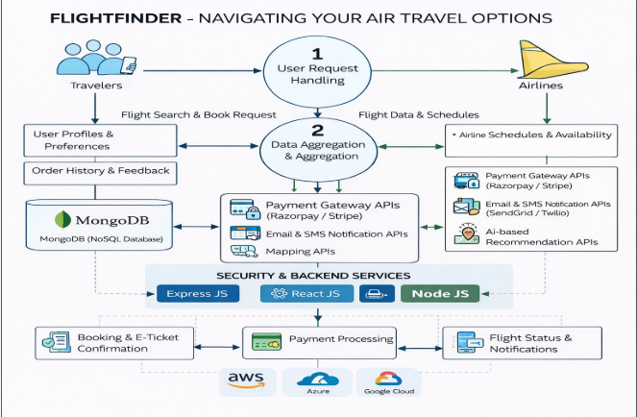

### 3.4 Technology Stack

Frontend:

* React.js
* HTML
* CSS
* JavaScript

Backend:

* Node.js
* Express.js

Database:

* MongoDB

Deployment:

* Localhost

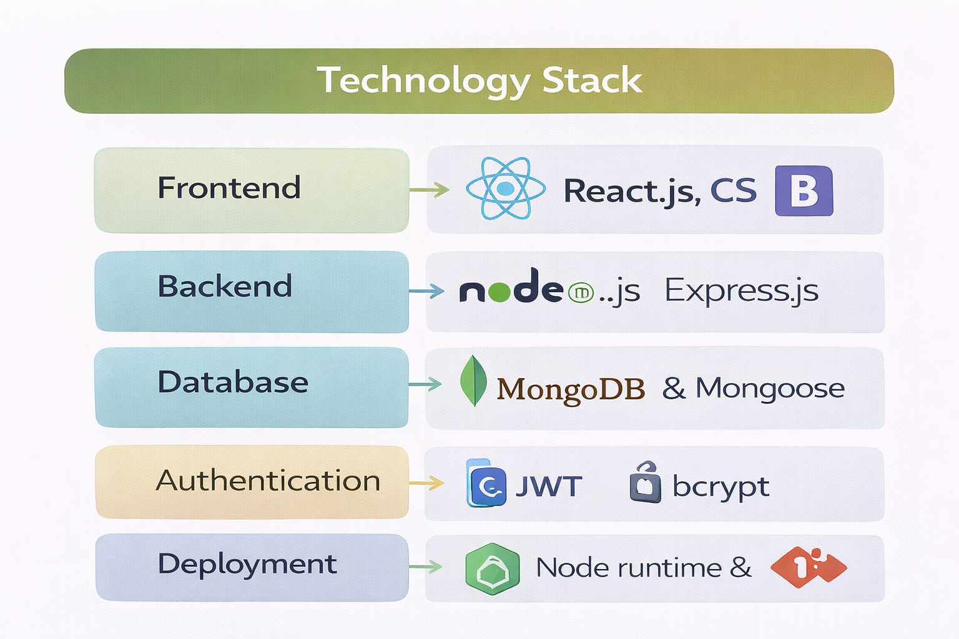

## 4. PROJECT DESIGN

### 4.1 Problem Solution Fit

FlightFinder effectively addresses the gap between user problems and technological solutions. By centralizing flight booking into one secure platform, the system reduces complexity, saves time, and improves customer trust.

### 4.2 Proposed Solution

The proposed solution is a web-based application that allows users to:

* Search and compare flights in real-time
* Filter results based on preferences
* Book tickets securely
* Manage bookings through a dashboard

The system ensures transparency and reliability throughout the booking process.

### 4.3 Solution Architecture

## 08bf83c6-3b4c-4274-8ed7-80ce21bd170c.png

## Architecture Structure (3-Tier Architecture)

### 1 Presentation Layer (Frontend)

* Built using React.js
* Provides user interface for searching, comparing, and booking flights
* Handles user interaction and input validation

### 2 Application Layer (Backend)

* Built using Node.js and Express.js
* Processes business logic such as flight search, booking, and payment handling
* Communicates with database and external APIs

### 3 Data Layer (Database)

* MongoDB / MongoDB Atlas
* Stores user details, flight data, booking history, and transaction records

## 5. PROJECT PLANNING & SCHEDULING

The project was developed using Agile Scrum methodology. The development was divided into multiple sprints:

* Sprint 1 – Authentication & Search
* Sprint 2 – Booking & Payment
* Sprint 3 – Booking Management
* Sprint 4 – Admin & Optimization

The average team velocity was approximately 19 story points per sprint.

## 6. FUNCTIONAL AND PERFORMANCE TESTING

Functional testing ensured that all core features such as registration, login, search, booking, and payment worked correctly.

Performance testing ensured that:

* Search results load within 3 seconds
* Payment processing completes within 4 seconds
* System supports concurrent users
* Uptime is maintained at 99%

## 7. RESULTS

The final implementation of FlightFinder successfully meets both functional and non-functional requirements. The application provides a secure, reliable, and user-friendly booking experience. All major modules were tested and validated.

**Frontend Page:**

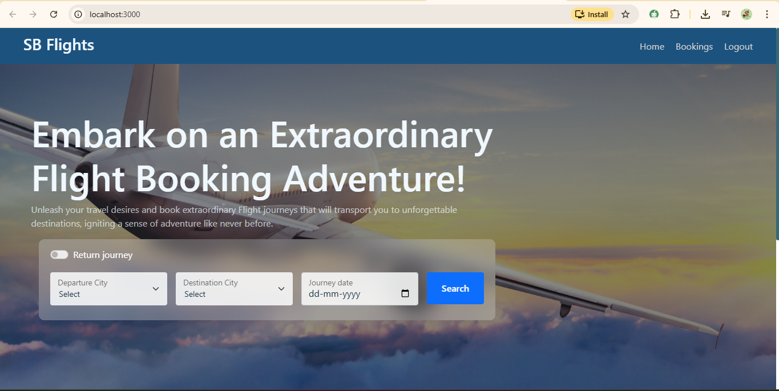

**About:**

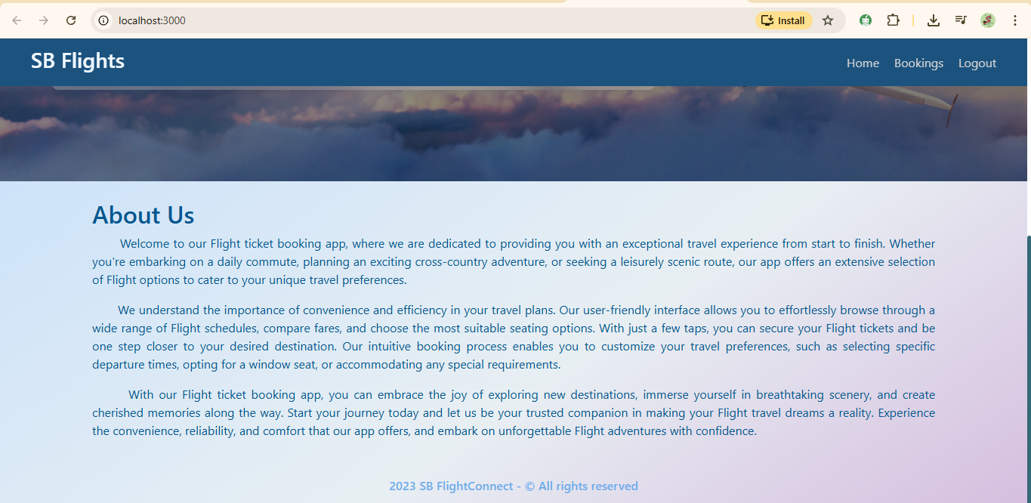

**Register Page:**

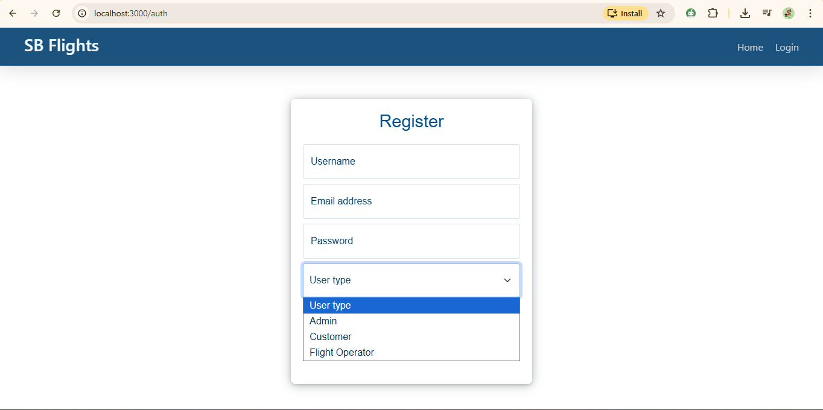

**Login Page:**

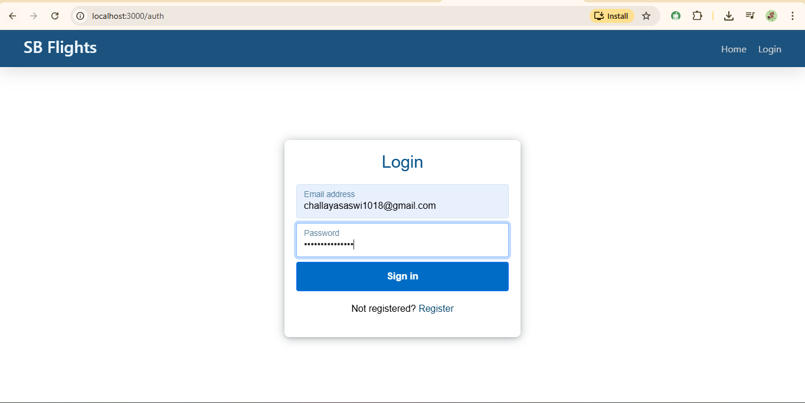

**User FlightSearch:**

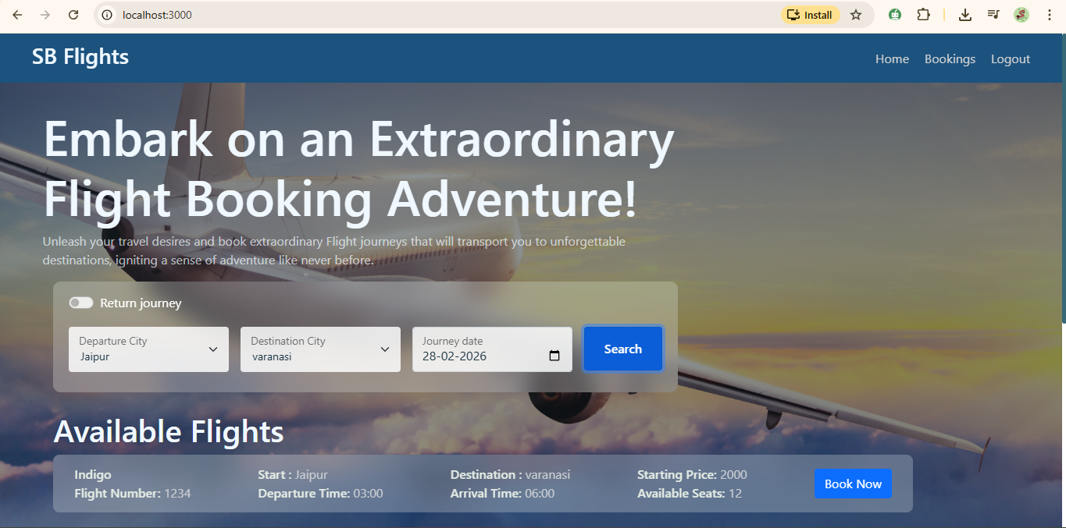

**Bookings Page:**

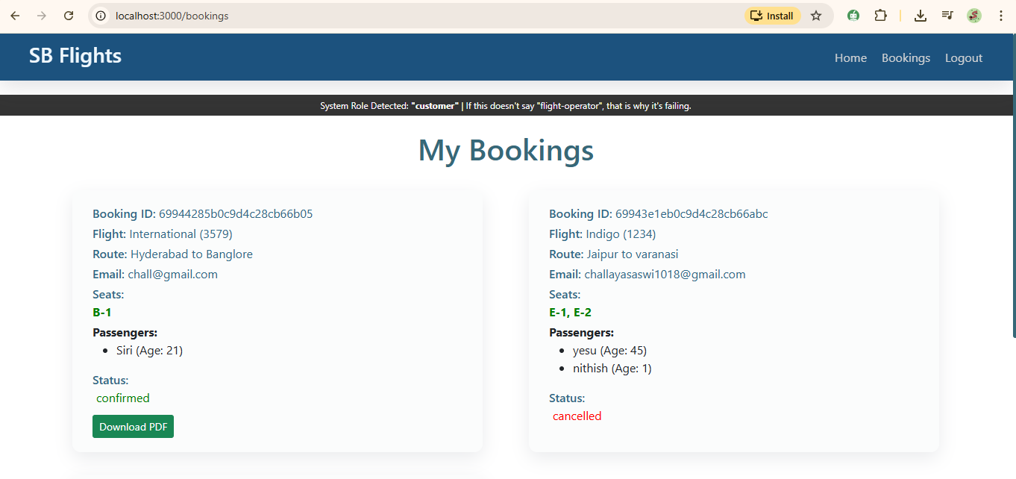

**Admin Page:**

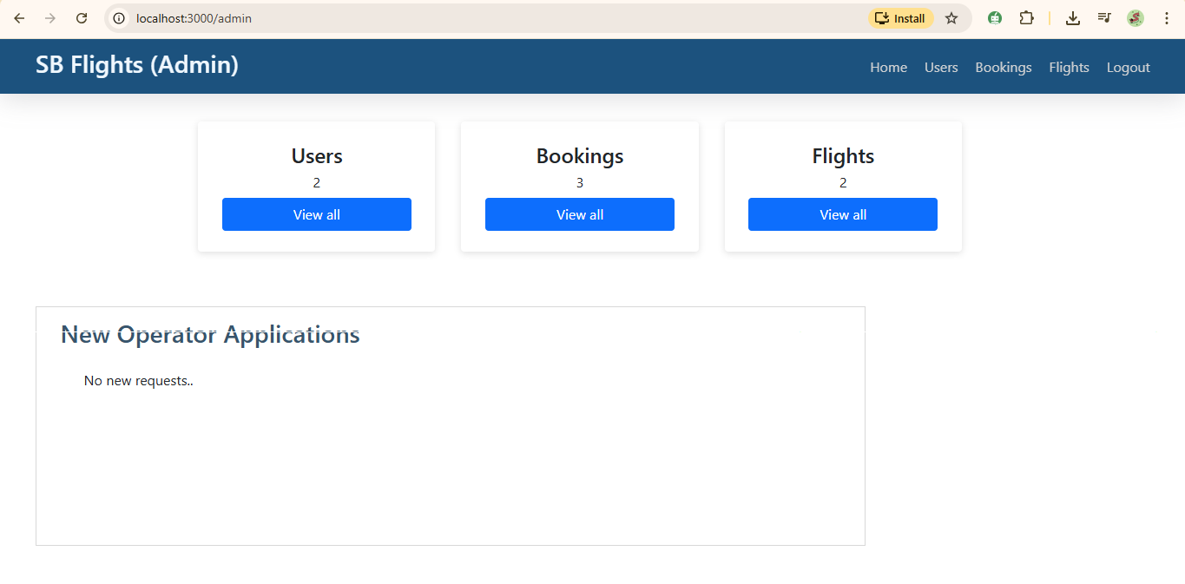

**Admin Page User :**

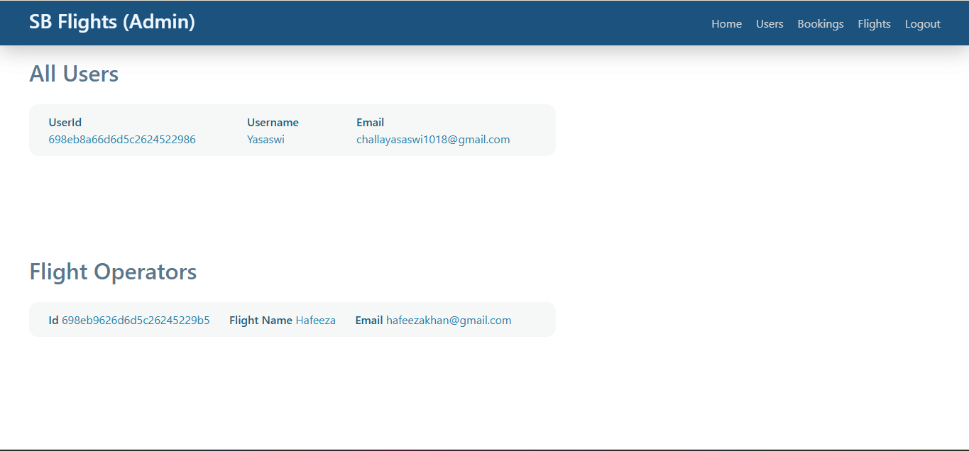

**Admin Page Booking:**

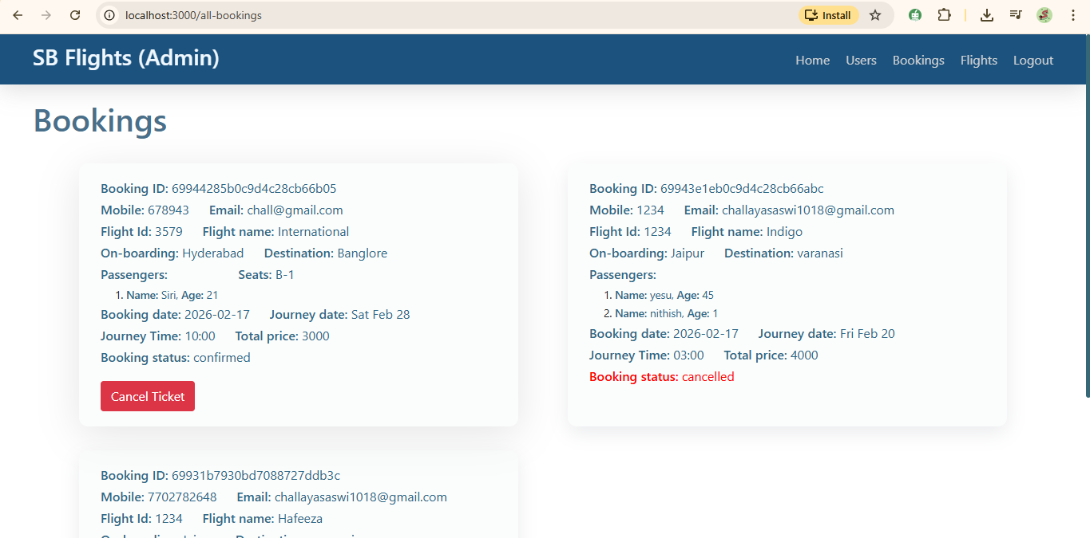

**Admin Page Flights:**

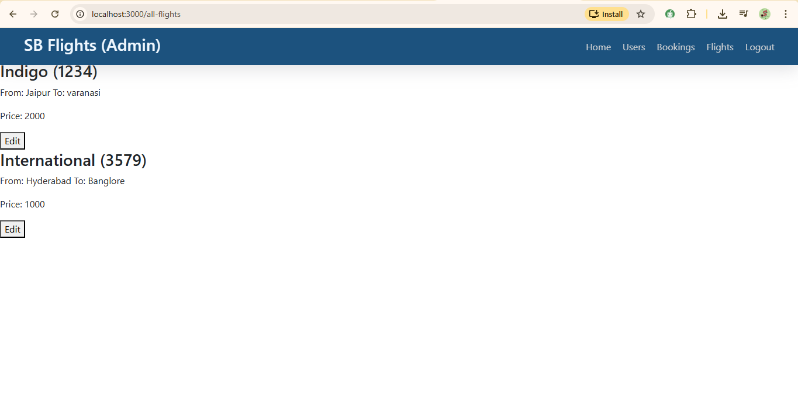

**Flight Operator Page:**

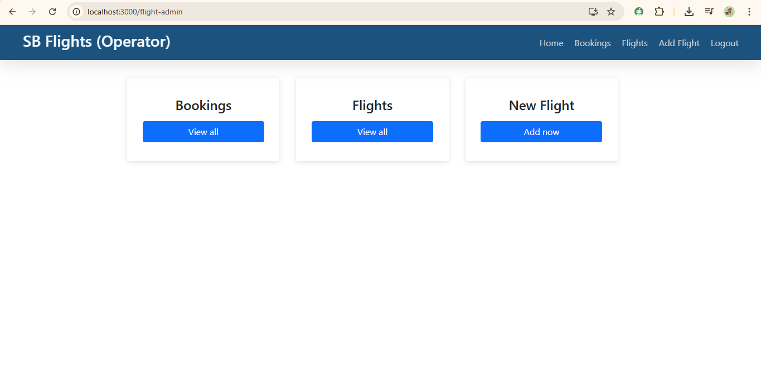

**FlightOperator Bookings:**

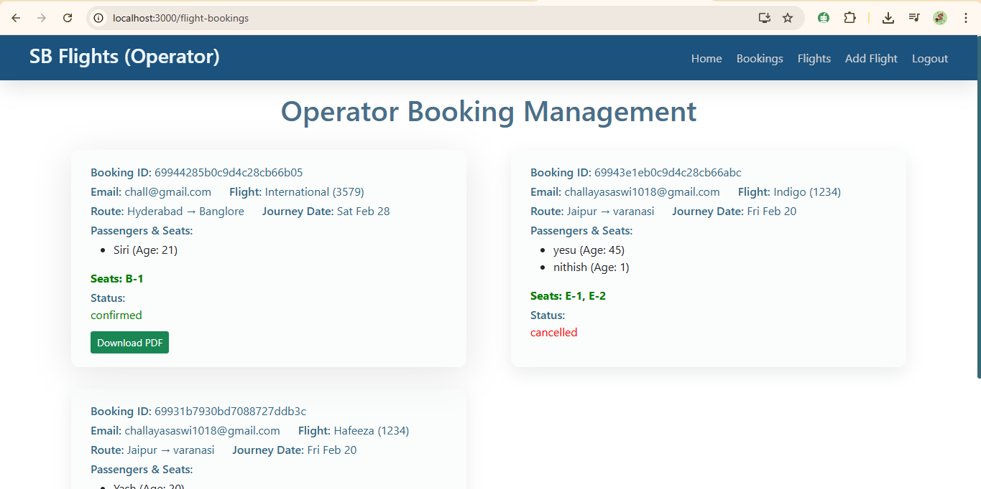

**FlightOperator Flights:**

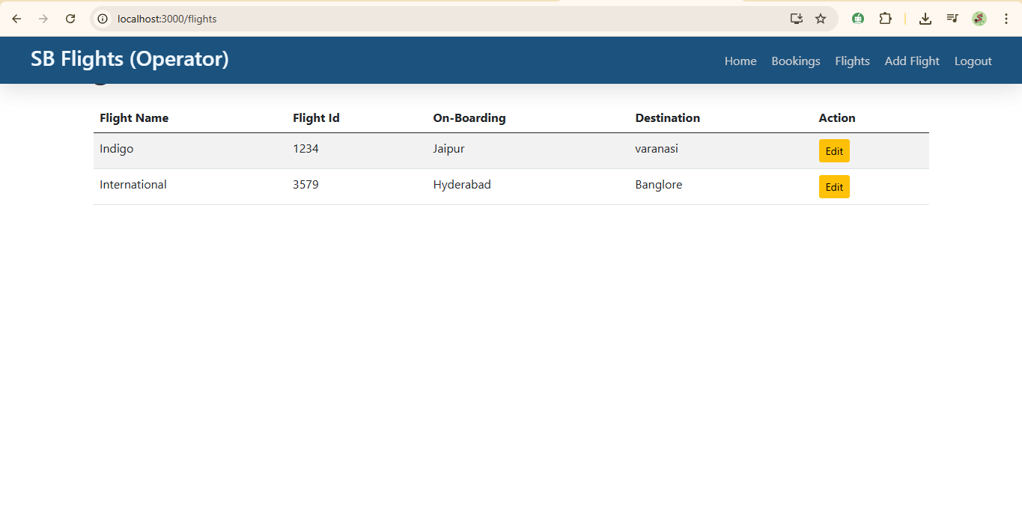

**FlightOperator BookFlight Page:**

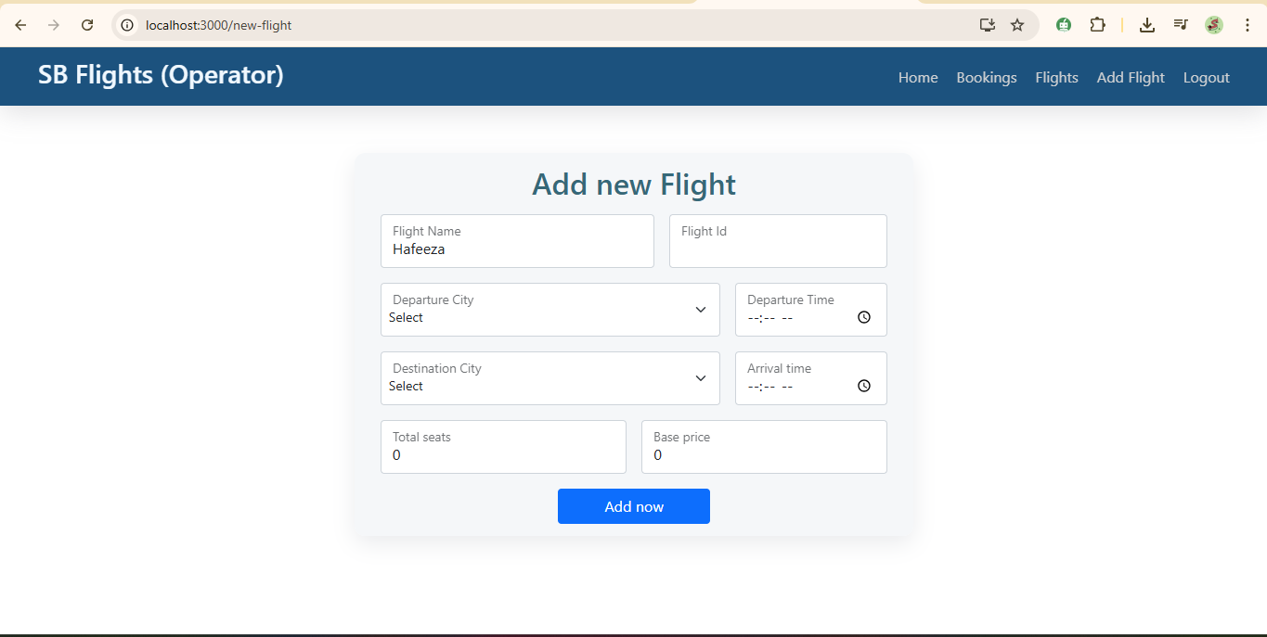

## 8. ADVANTAGES & DISADVANTAGES

## Advantages

1. **Centralized Flight Comparison**  
   FlightFinder provides a single platform where users can search, compare, and book flights without visiting multiple airline websites. This reduces confusion and saves time.
2. **User-Friendly Interface**  
   The system is designed with a clean and intuitive interface, making it easy for users of all age groups to navigate and complete bookings smoothly.
3. **Real-Time Flight Availability**  
   Users receive up-to-date flight information, including pricing and availability, helping them make informed decisions quickly.
4. **Secure Payment Processing**  
   The integration of trusted payment gateways ensures encrypted transactions and protects user financial data.
5. **Booking Management System**  
   Users can view booking history, check flight details, and cancel bookings directly from their dashboard.
6. **Scalable Architecture**  
   The system is built using modern web technologies (MERN stack), allowing it to scale efficiently with increasing users and data.
7. **Admin Control & Monitoring**  
   Administrators can manage flight details, monitor bookings, and maintain system performance through a dedicated dashboard.

## Disadvantages

1. **Dependency on Third-Party APIs**  
   The system relies on external APIs for payment processing and flight data. Any downtime or failure in these services can affect application functionality.
2. **Internet Dependency**  
   As a web-based platform, the system requires a stable internet connection for proper functioning.
3. **Limited Offline Access**  
   Users cannot access booking features without network connectivity.
4. **Initial Development Cost**  
   Implementing secure payment integration and cloud deployment may involve additional costs.
5. **Security Risks (If Not Maintained Properly)**  
   Without regular updates and monitoring, web applications may become vulnerable to cyber threats.

## 9. CONCLUSION

FlightFinder – Navigating Your Air Travel Options successfully addresses the challenges faced by travelers in booking flights online. The system provides a centralized, secure, and user-friendly platform for flight search, comparison, booking, and management.

By leveraging modern web technologies such as React.js, Node.js, Express.js, and MongoDB, the application ensures scalability, performance, and maintainability. The implementation of secure authentication and encrypted payment integration enhances user trust and reliability.

The project demonstrates a strong understanding of full-stack development principles and practical problem-solving in real-world scenarios. Overall, FlightFinder achieves its objective of simplifying the flight booking experience while ensuring efficiency, transparency, and security.

**10. FUTURE SCOPE**

Although FlightFinder meets its current objectives, several improvements can enhance the system further:

1. **AI-Based Flight Recommendation System**  
   Implement machine learning algorithms to suggest the best flights based on user preferences and booking history.
2. **Price Alert Notifications**  
   Allow users to set alerts for specific routes and receive notifications when prices drop.
3. **Mobile Application Development**  
   Develop a dedicated Android and iOS mobile app for improved accessibility and user engagement.
4. **Multi-Language Support**  
   Add support for multiple languages to serve a broader audience.
5. **Integration with Hotel & Cab Booking**  
   Expand the platform into a complete travel solution by integrating hotel reservations and cab services.
6. **Advanced Analytics Dashboard for Admin**  
   Provide detailed insights into booking trends, revenue analysis, and user behavior.
7. **Loyalty & Reward Program**  
   Introduce reward points and discounts for frequent users to increase customer retention.
8. **Enhanced Security Measures**  
   Implement multi-factor authentication (MFA) and advanced monitoring systems to strengthen security.
9. **Chatbot Support System**  
   Add AI-powered customer support chatbot for instant assistance.

**11. APPENDIX**

GitHub Repository: https://github.com/challayasaswi/Flightfinder-Navigating-your-Air-Travel-options